Blue Team Shooting Sports A.S.S.S. February 28th, 2026
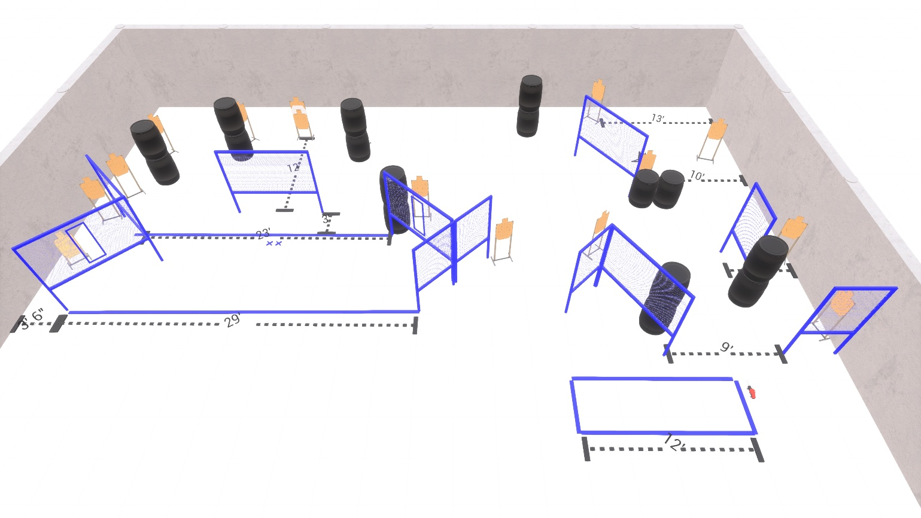

Written Stage Briefings:

Stage 1 - You're a funny guy, Sully. I like you. That's why I'm going to kill you last.
20 rounds, 100 points, Comstock.
10 Paper, best 2 hits score.
Start position Both feet on the Xs.
Handgun: Loaded and holstered, wrists below belt
PCC: Loaded, stock touching belt

Stage 2 - I eat Green Berets for breakfast. And right now, I'm very hungry!
12 rounds, 60 points, Comstock.
10 Paper, best 2 hits score.
Start position Anywhere
Handgun: Loaded and holstered, wrists below belt
PCC: Loaded, stock touching belt

Stage 5 - Don't disturb my friend. He's dead tired.
32 rounds, 160 points, Comstock.
16 Paper, best 2 hits score.
Start position Both feet on the Xs.
Handgun: Loaded and holstered, wrists below belt
PCC: Loaded, stock touching belt

